# Building Multi-language Reports in Power BI

Power BI provides Internationalization and localization features which make it possible to build multi-language reports. For example, you can design a Power BI report that renders in English for some users while rendering in Spanish, German, Japanese or Hindi for other users. If a company or organization has the requirement of building Power BI reports that support multiple languages, it's not necessary to clone and maintain a separate PBIX project file for each language. Instead, they can increase reuse and lower report maintenance by designing and implementing a strategy for building multi-language reports.

This article has been created to provide guidance and to teach the skills required to build Power BI reports that support multiple languages. You need to learn a few key concepts about how Power BI translations work and how to automate repetitive tasks that would take forever to complete manually. An essential part of this guidance is based on using an external tool named [**Translations Builder**](https://github.com/PowerBiDevCamp/TranslationsBuilder) that’s been created for content creators using Power BI Desktop. Once you understand how all the pieces fit together, you’ll be able to build multi-language reports for Power BI using a strategy that is reliable, predictable and scalable.

### Multi-language Report Live Demo

This article is accompanied a [**live demo**](https://multilanguagereportdemo.azurewebsites.net/) based on a single PBIX file solution named [**ProductSalesMultiLanguage.pbix**](https://github.com/PowerBiDevCamp/TranslationsBuilder/raw/main/LiveDemo/ProductSalesMultiLanguage.pbix). This live demo shows the potential of building multi-language reports for Power BI. The report in the live demo can be loaded using English, Spanish, French, German, Dutch, Italian, Portuguese, Greek, Russian, Japanese, Chinese, Hindi, Hebrew and Afrikaans. You can test out the live demo and the experience a Power BI report that support over a dozen secondary languages by navigating the following URL.

* [**https://multilanguagereportdemo.azurewebsites.net**](https://multilanguagereportdemo.azurewebsites.net)

When you test out the live demo, experiment by clicking links in the left navigation to reload the report using different langauges. For example, click on the link with the caption of **German (Deutsch)**. When you do, you will see the report load with German translations as shown in the following screenshot.

The live demo is based on a custom web application that uses Power BI embedding. When you click on a link in the left navigation, there is JavaScript behind this web page that responds by explicitly reloading the report using the language of German intead of English. You can see that all the text-based elements for the entire report are now displayed with their German translations instead of with the default English translations.

### Power BI Support for Metadata Translations

The primary localization feature in Power BI used to build multi-language reports is known as **metadata translations**. Power BI inherited this feature from its predecessor, Analysis Services, which introduced metadata translations to add localization support to the data model associated with a tabular database or a multidimensional database. In Power BI, metadata translations support has been integrated at the dataset level.

A metadata translation represents the property for a dataset object that's been translated for a specific language. Consider a simple example. If your dataset contains a table with an English name of **Products**, you can add translations for the **Caption** property of this table object to provide alternative names for when the report is rendered in a different language. The types of dataset objects that support metadata translations include **Table**, **Column**, **Measure**, **Hierarchy** and **Hierarchy** **Level**. In addition to the **Caption** property which tracks an object's display name, dataset objects also support adding metadata translations for two other properties which are **Description** and **DisplayFolder**.

Power BI reports and datasets that support multiple languages can only run in workspaces which are associated a dedicated capacity created using Power BI Premium or the Power BI Embedded Service. That means multi-language reports will not load correctly when launched from a workspace in the shared capacity. If you are working in a Power BI workspace that does not display a diamond indicating it’s a Premium workspace, you will find that multi-language reports don’t work as expected because there is no support for loading translations from secondary languages.

Another critical point to understand is that the Power BI support for metadata translations only applies to datasets. Neither Power BI Desktop nor the Power BI Service provide any support for storing or loading translations for text values stored as part of the report layout.

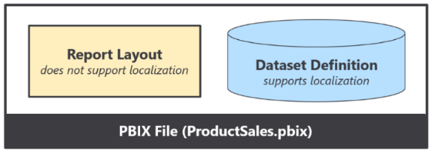

Think about a common scenario where you add a textbox or a button to a Power BI report and then you type in literal text for a string value displayed to the user. That text value is stored in the report layout and cannot be localized. Therefore, you must avoid using textboxes and buttons that contain literal text values stored in the report layout. As a second example, page tabs in a Power BI report are also problematic because their display names cannot be localized. Therefore, you must design multi-language reports so that page tabs are hidden and never displayed to the user.

### Implementing Translations Dynamically using Measures and USERCULTURE

A second essential feature to assist with building multi-language reports in Power BI is the DAX **USERCULTURE** function. The **USERCULTURE** function returns a string which includes a lower-case language ID parsed together with an upper-case locale identifier. Here are a few examples of strings with a language and locale that might be returned by **USERCULTURE**.

* **en-US** [language=English, locale identifier=United States]
* **es-ES** [language=Spanish, locale identifier=Spain]
* **fr-FR** [language=French, locale identifier=French]
* **de-DE** [language=German, locale identifier=Germany]
* **ja-JP** [language=Japanese, locale identifier=Japan]

Remember that you can only use the **USERCULTURE** function to implement dynamic translations in measures. When you use **USERCULTURE** in the DAX expression for a measure, it’s guaranteed to return the language and locale identifier for the current user. The same is not true if you use the **USERCULTURE** function in the DAX expression for a table or a column which get evaluated at dataset load time. When you use **USERCULTURE** in the DAX expression for a table or calculated column, you don’t get the same guaranteed that it uses the language and locale of the current user.

The live demo displays the return value of **USERCULTURE** in the upper right corner of the report banner. You will not typically display a report element like this in a real application, but it’s included with the live demo so you can see exactly what language and locale identifier are being used to load the report each time you switch to a new language.



Let’s look at a simple example of writing a DAX expression for a measure that implements dynamic translations. You can start by extracting the language ID for the current user using **USERCULTURE** together with **LEFT**.

CurrentLanguage = LEFT(USERCULTURE(), 2)

Now, you can take things a step further by adding a **SWITCH** statement to form a basic pattern for dynamic translations.

Product Sales Report Label = SWITCH(LEFT(USERCULTURE(), 2),

"es", "Informe De Ventas De Productos",

"fr", "Rapport Sur Les Ventes De Produits",

"de", "Produktverkaufsbericht",

"Product Sales Report"

)

OK, it’s nowhere near as impressive as some of those fancy DAX patterns that come out of Italy. But hey, it’s a start.

### Formatting Dates and Numbers with the Current User’s Locale

Every report that loads in the Power BI Service is initialized with a specific language and a specific locale. The default behavior of the Power BI Service it to load each report using the language and regional locale specified by the user’s browser settings. However, those settings can be overridden by adding the **language** query string parameter to the end of the report URL. If you’re developing with Power BI embedding, you also have complete control to load a report with a specific language and locale as demonstrated by the live demo.

You’ve already seen that you can implement dynamic translations by writing a DAX expression in a measure with conditional logic based on the user’s language. This is a technique that will be used frequently when building reports that support multiple languages. However, you will not be required to write conditional DAX logic based on the user’s locale. Why is that?

The short answer is that Power BI visuals automatically handle locale-specific formatting behind the scenes. This makes things so much easier.

The long answer is that a Power BI visual inspects the locale of the current user before rendering. During the rendering process, the visual applies formatting to a date or numeric value based on the user’s locale and the format string of the source column or measure.

Consider a simple scenario in which you’re building a report for an audience of report consumers that live in both New York [**en-US**] and in London [**en-GB**]. All users speak English (**en**), but yet some live in different regions (**US** vs **GB**) where dates and numbers are formatted differently. For example, a user from New York wants to see dates in a **mm/dd/yyyy** format while a user from London wants to see dates in a **dd/mm/yyyy** format. Everything thing works out as long as you configure columns and measures using format strings that support regional formatting.

If you are formatting a date, it is recommended you use a format string of **Short Date** or **Long Date** because those format strings support regional formatting. Power BI Desktop offers other formatting options (those without an asterisk) that should be avoided as they have a pre-defined display patterns to do not change in response to the user’s locale.

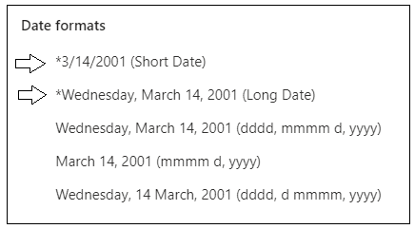

Here are a few examples of how a date value formatted with **Short Date** appears when loaded under different locales.

|  |  |
| --- | --- |
| en-US | 12/31/2022 |
| en-GB | 31/12/2022 |
| pt-PT | 31-12-2022 |
| de-DE | 31.12.2022 |
| ja-JP | 2022/12/31 |

The Japanese formatting is hands-down the winner because it’s the only format that automatically sorts chronologically.

### Understanding the Three Types of Translations

When it comes to localizing Power BI artifacts such as datasets and reports, there are three different types of translations and you must be able distinguish between them. These are the three types of translations you should understand.

* Metadata Translations
* Report Label Translations
* Data Translations

Now, let’s examine all three types in a little more depth.

**Metadata translations** provides localized values for dataset object properties. The object types which support metadata translation include tables, columns, measures, hierarchies and hierarchy levels. The following screenshot shows how metadata translations provide German names for the measures displayed in card visuals.



Metadata translations are also used to display column names and measure names in tables and matrices.

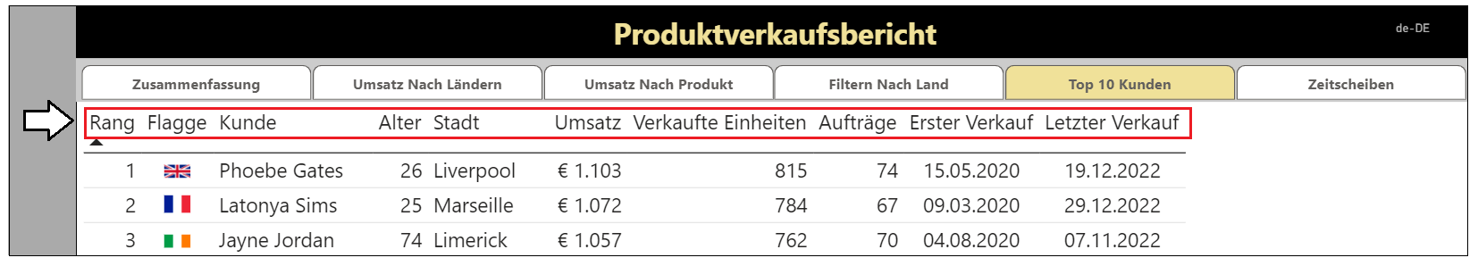

Metadata translations are the easiest to create, manage and integrate into a Power BI report. By leveraging the features of Translations Builder to generate machine translations, you can add all the metadata translations you need to build and test a Power BI report in a matter of seconds. As you will discover, adding metadata translations to your dataset is fairly straight-ahead and an essential first step. However, metadata translations rarely provide a complete solution by themselves. A complete solution will typically require going further to localize report labels.

**Report label translations** provide localized values for text elements on a report that are not directly associated with a dataset object. Examples of report labels include the report title, section headings and button captions. Here are a few examples of report label translations in the live demo with the report title and the captions of navigation buttons.

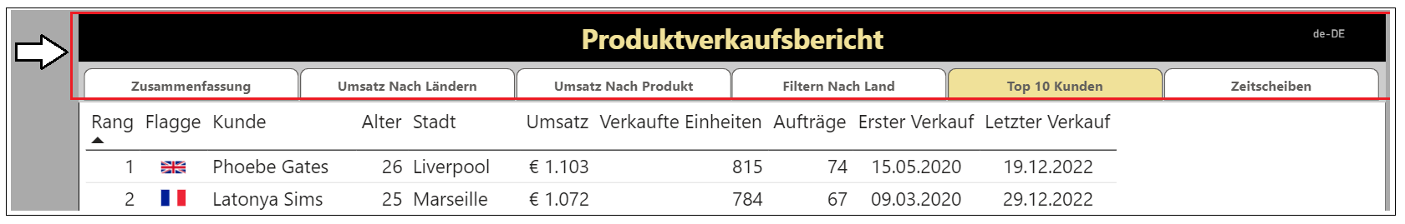

Report label translations are harder to create and manage than metadata translations because Power BI provides no built-in feature to track or integrate them. Translations Builder solves this problem using the Localized Table strategy. This strategy is based on creating a hidden table named **Localized Labels** in the dataset behind a report with measures which can track and load translations for each report label. You will learn more about the Localized Labels table strategy later in this article in the section titled **Understanding the Localized Labels Table**.

**Data translations** provide translated values for text-based columns in the underlying data itself. Think about a scenario where a Power BI report displays product names imported from the rows of the **Products** table in an underlying database. Data translations are used to display product names differently for users who speak different languages. For example, some users see products names in English while other users see product names in secondary languages.

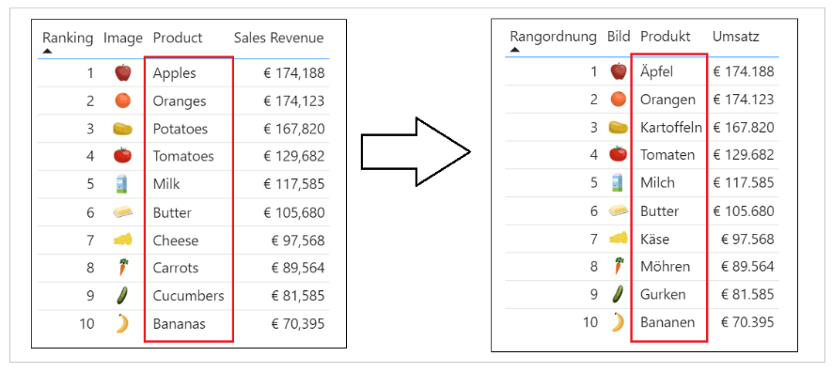

Data translations also appear in the axes of cartesian visuals and in legends as shown in the following screenshot.

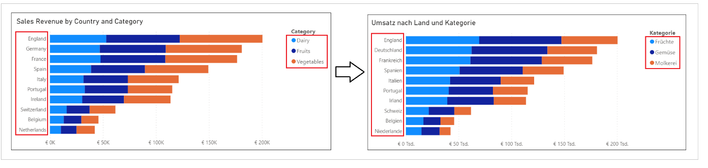

Data translations are harder to design and implement than the other two types of translations. The reason it’s harder is that you must typically redesign the underlying datasource with additional text columns for secondary language translations. Once the underlying datasource has been extended with extra text columns for secondary language translations, you can then use a powerful new feature in Power BI Desktop known as ***Field Parameters*** to design a scheme where you can control the loading the data translations for a specific language through filtering.

While every multi-language report will typically require both metadata translations and report label translations, it is not as clear whether they will also require data translations. Some projects to build a multilanguage report for Power BI will require data translations while others will not. This point will be revisited in more depth later in this article.

### Packaging Dataset and Report in PBIX Project Files

Now that you understand high-level concepts of building multi-language reports with translations, it's time to discuss the multi-language report development process. The first step here is to decide how to package your dataset definitions and report layouts for distribution. Let's examine two popular approaches used by content creators who work with Power BI Desktop.

In the first approach, the goal is to keep things simple and convenient by creating a single PBIX project file which contains both a report layout and its underlying dataset definition. You can easily deploy a reporting solution like this by importing the PBIX project file into a Power BI workspace. If you need to update either the report layout or the dataset definition after they have been deployed, you can perform an upgrade operation by importing an updated version of the PBIX project file.

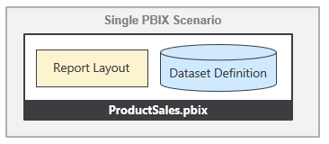

The single PBIX file approach doesn't always provide the flexibility you need. Imagine a scenario where one team is responsible for creating and updating dataset definitions while other teams are responsible for building reports. For a scenario like this, it makes sense to split out dataset definitions and report layouts into separate PBIX project files.

To use the shared dataset approach, you create one PBIX project file with a dataset definition and an empty report which remains unused. Once this dataset has been deployed to the Power BI Service, report builders can connect to it using Power BI Desktop to create report-only PBIX files. This makes it possible for the teams building reports to build PBIX project files with report layouts which can be deployed and updated independently of the underlying dataset.

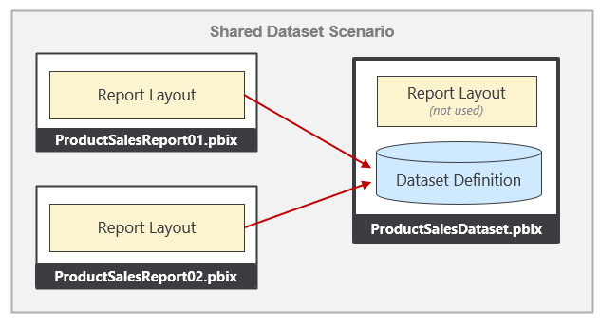

From the perspective of adding multi-language support to a Power BI solution, it really doesn't matter which of these approaches you choose. The techniques and disciplines used to build multi-language reports remain the same whether you decide to build your solution using a single PBIX project file or with a combination of PBIX project files. There are specific tasks you need to perform at the dataset level and other tasks you must perform when building report layouts in Power BI Desktop. The multi-language report development process can be broken down into a few distinct phases. Each of these phases will be examined in detail in this article.

While the solution provided by **ProductSalesMultiLanguage.pbix** demonstrates a single PBIX project file approach where the dataset and report are packaged together for convenience. However, nothing changes if you package and distribute datasets and reports using separate PBIX files. You will use the exact same concepts and techniques to build multi-language reports in scenarios where your solution contains multiple PBIX files.

## Understanding How Translations Builder Works

Translations Builder is a tool created for content creators using Power BI Desktop. Content creators can use this tools to add multi-language support to PBIX project files. The following screenshot shows what Translations Builder looks like when working with a simple PBIX project that supports a small number of secondary languages.

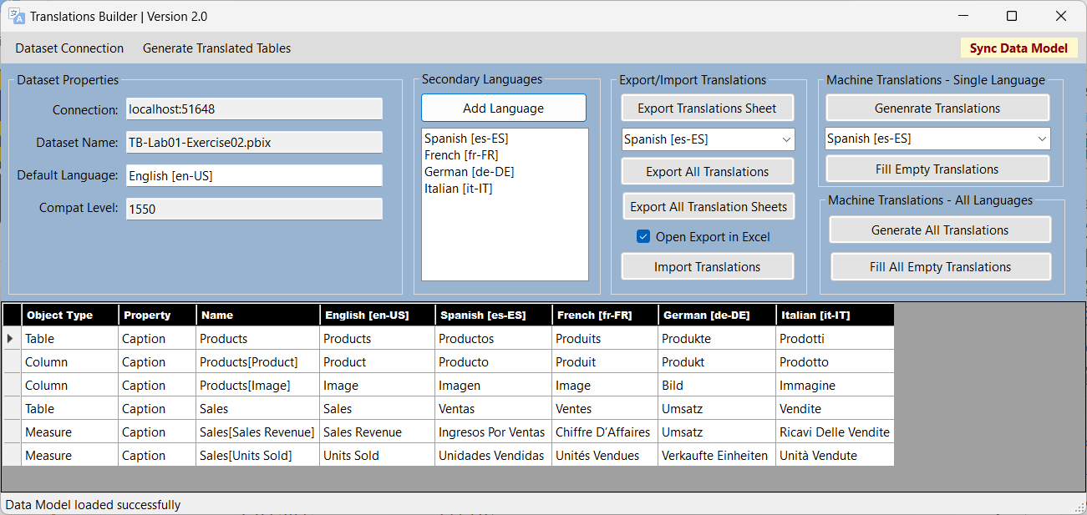

Translations Builder is an external tool developed for Power BI Desktop using C#, .NET 6, and Windows Forms. Translations Builder uses an API known as the ***Tabular Object Model (TOM)*** to update datasets that have been opened and are running in Power BI Desktop. Translations Builder does most of its work by adding and updating the metadata translations associated with datasets objects including tables, columns and measures. However, there are several scenarios in which Translations Builder will actually create new tables in a dataset to implement strategies to handle various aspects of building multi-language reports.

When you open a PBIX project in Power BI Desktop, the dataset definition from inside the PBIX file is loaded into memory in a local session of the Analysis Services engine. Translations Builder uses TOM to establish a direct connection to a dataset for the current PBIX project.

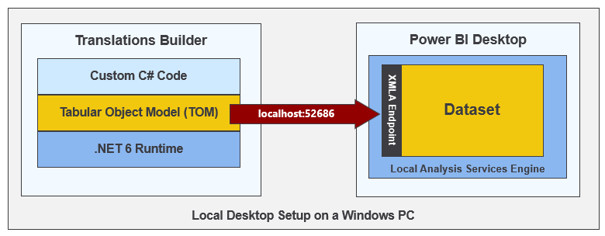

The Translations Builder project has been developed using the [**external tools integration support**](https://docs.microsoft.com/en-us/power-bi/transform-model/desktop-external-tools) for Power BI Desktop. You can install Translations Builder on a Windows PC where you've already installed Power BI Desktop using instructions in the [**Translations Builder Installation Guide**](https://github.com/PowerBiDevCamp/TranslationsBuilder/blob/main/Docs/Installation%20Guide.md). Once the Translations Builder application has been installed on a Windows computer, you can launch it directly from Power BI Desktop using the **External Tools** tab in the ribbon.

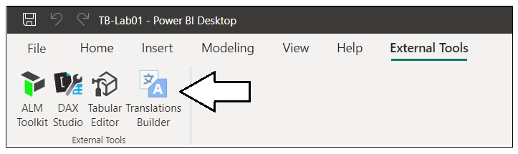

When you launch an external tool like Translations Builder, the application is passed startup parameters including a connection string which can be used to establish a connection back to a dataset that's loaded in Power BI Desktop. This allows Translations Builder to display dataset information and to provide commands to automate adding metadata translations. You can read [**Translations Builder Developers Guide**](https://github.com/PowerBiDevCamp/TranslationsBuilder/blob/main/Docs/Developer%20Guide.md) if you want to learn more about the details of working with Translations Builder as a developer. The content in this article will focus on teaching concepts and localization skills to content creators using Power BI Desktop.

The key value proposition of Translations Builder is that is allows a content creator to view, add and update metadata translations using a two-dimensional grid. This ***translations grid*** simplifies the user experience because it abstracts aways the low-level details or reading and writing metadata translation associated with a dataset definition. Users work with the translation grid to view, add and edit metadata translations in a manner that is similar to working with data inside an Excel spreadsheet.

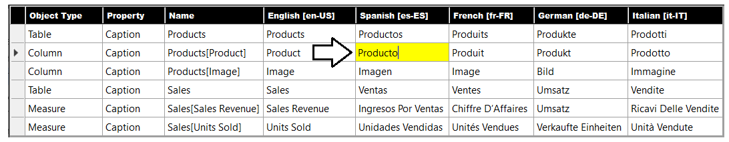

### Adding Secondary Languages and Translations

When you launch Translations Builder with a PBIX project for the first time, the translation grid will display a row in for each non-hidden table, measure and column in the project’s underlying data model. The translation grid does not display rows for dataset objects in the data model that are hidden from report view. The reason for this is that hidden objects will not be displayed on a report and, therefore, do not require translations. The following screenshot shows the starting point for a simple data model before it’s been modified to support secondary languages.

If you examine this PBIX project more closely, you can see the first three columns in the translation grid contain read-only columns used to identity each metadata translation. Each metadata translation has a parent which is a dataset object such as a table, column or measure. Each translation is based on a property such as **Caption**. The fourth column displays the translation for the dataset’s default language which in this case is English **[en-US]**.

Translations Builder provides an **Add Language** command to add secondary languages to the project’s data model.

Clicking **Add Language** displays the **Add Language** dialog which allows the user to add one or more secondary languages.

After a new language has been added, the user can see the language in the **Secondary languages** list.

Adding a new language will also add a new column of editable cells to the translations grid.

In scenarios where content creators know how to speak all the languages involved, they can add and update translations for secondary languages directly in the translation grid with an Excel-like editing experience.

Technically speaking, Translations Builder isn’t just adding a language object to the dataset. Instead, Translations Builder is actually adding a **Culture** object with includes both a language ID and a locale identifier. In Power BI datasets, a **Culture** object is identified using a string-based key which combines a lower-case language ID and an upper-case locale identifier for the geographical region. Note this is the same string-based format returned by the **USERCULTURE** function.

Translations Builder abstracts away the differences between a language and a culture. This has been done to simplify the user experience for content creators who can just think in terms of languages and not worry about the differences between a language and a culture. It’s not overly important to distinguish between a language and a culture until you begin programming with TOM and you need to add new **Culture** objects to a Power BI dataset.

Another important aspect of working with Translations Builder has to do with saving your work. While external tools for Power BI Desktop like Translations Builder are able to modify the dataset loaded into memory from a PBIX file, there is no way for an external tool to trigger a command to save the in-memory changes back to the underlying PBIX file. Therefore, you must always return back to Power BI Desktop and click the **Save** command any time you have added languages and any time you have created or edited translations.

Once the changes have been written back to the PBIX file, that file can then be published to the Power BI Service for testing. Once you have tested your work and verified that the translations are working properly, you can also store the PBIX file in a source control system such as GitHub or an Azure DevOps repository. This provides the foundation for an ALM strategy where support for secondary languages and translations can be evolved across versions of a PBIX file.

### Testing Translations in the Power BI Service

One of the issues that makes working with translations a bit more complicated is that you cannot test your work in Power BI Desktop. Instead, you must test your work in the Power BI Service in a workspace associated with a Premium capacity. After you have added translation support with Translations Builder and you have save your changes to the underlying PBIX file, you can then publish the PBIX project from Power BI Desktop to the Power BI Service for testing.

After publishing your PBIX project to the Power BI Service, you can test loading the report using secondary language by modifying the report URL with a query string parameter named **language**. After the report loads with its default language, you can click the browser address bar and add the following language parameter to the end of the report URL.

/?language=es-ES

Once you add the **language** parameter to the end of the URL and press **ENTER**, you should be able to verify that the **language** parameter has been accepted by the browser as it reloads the report. If you forget to add the **?** or if you do not format the **language** parameter correctly, the browser will reject the parameter and remove it from the URL as it loads the report. If you correctly load a report using a **language** parameter value of **es-ES**, you should see the UI experience for the Power BI Service UI switch from English to Spanish.

You will also see that the report displays the Spanish translations for the names of columns and measure.

Now that you’ve seen how to test your work when working with translations, it possible to make a high-level observation about working with Translations Builder. As you begin to work with secondary languages and translations to localize a PBIX project, you will follow the same set of steps again and again:

1. Make changes in Power BI Desktop
2. Publish the PBIX project to the Power BI Service
3. Test your work with a browser in the Power BI Service using **language** parameter
4. Repeat steps 1-3 until all the translations work has been completed

You seem to be getting excited about all of this. If you want to jump right in and get started with Translations Builder, you can work try out the hands-on lab titled [**Lab 01: Getting Started with Translations Builder**](https://github.com/PowerBiDevCamp/TranslationsBuilder/blob/main/Labs/Lab%2001%20-%20Getting%20Started%20with%20Translation%20Builder.md).

### Embedding Power BI Reports Using a Specific Language and Locale

If you are developing with Power BI embedding, you can use the Power BI JavaScript API to load reports with a specific language and locale. This is accomplished by extending the **config** object passed to **powerbi.embed** with a **localeSettings** object containing a **language** property as shown in the following code.

let config = {

type: "report",

id: reportId,

embedUrl: embedUrl,

accessToken: embedToken,

tokenType: models.TokenType.Embed,

localeSettings: { language: "de-DE" }

};

let report = powerbi.embed(reportContainer, config);

### Generating Machine Translations using Azure Translator Service

One of the biggest challenges in building multi-language reports is managing the language translation process. You must ensure that the quality of translations is high and that the translated names of tables, columns, measures and labels do not lose their meaning when translated to another language. In most cases, acquiring quality translations will require human translators to create or at least review translations as part of the multi-language report development process.

While human translators are an essential part of the end-to-end process, it can take a long time to send out translation files to a translation team and then to wait for them to come back. With all the recent industry advances in Artificial Intelligence (AI), you also have the option to generate machine translations using a Web API that can be called directly from an external tool such as Translations Builder. If you initially generate machine translations for each secondary language you need to support, that will give you something to work with while waiting for a translation team to return their high-quality human translations.

While machine translation are not always guaranteed to be high quality, they do provide value in the multi-language report development process. First, they can act as translation placeholders so you can begin your testing by loading reports using secondary languages to see if there are layout issues or unexpected line breaks. Machine translations can also provide human translators with a better starting point as they just need to review and correct translations instead of creating every translation from scratch. Finally, machine translations can be used to quickly add support for languages in scenarios where there are legal compliance issues and organizations are facing fines or litigation for non-compliance.

Translations Builder generates machine translations by executing API calls against the [**Azure Translator service**](https://docs.microsoft.com/en-us/azure/cognitive-services/translator/translator-info-overview) which is an API endpoint offered through Azure Cognitive Services. This Web API makes it possible to automate enumerating through dataset objects to translate dataset object names from the default language to translations for secondary languages.

If you'd like to test out the support in Translations Builder for generating machine translations, you will require a Key for an instance of the Azure Translator Service. If you have an Azure subscription, you can learn how to obtain this key and its location by reading [Obtaining a Key for the Azure Translator Service](https://github.com/PowerBiDevCamp/TranslationsBuilder/blob/main/Docs/Obtaining%20a%20Key%20for%20the%20Azure%20Translator%20Service.md). Translations Builder provides a Configuration Options dialog which makes it possible to configure the key and location to access the Azure Translator Service.

Once a user has configured an Azure Translator Service key, Translations Builder will begin to display additional command buttons which make it possible to generate translations for a single language at a time or for all languages at once. There are also commands to generate machine translations only for the translations that are currently empty.

## Understanding the Localized Labels Table

Earlier you learned thatreport label translations provide localized values for text elements on a report that are not directly associated with a dataset object. Examples of report labels are the text values for report titles, section headings and button captions. Given that Power BI provides no built-in features to track or integrate report labels, Translations Builder solves this problem using the **Localized Labels** table strategy. Before introducing this strategy, let’s take a moment to discuss the problems this strategy has been designed to solve.

If you have experience building datasets and reports with Power BI Desktop, it's critical that you learn which report design techniques to avoid when building multi-language reports. Let's begin with the obvious things which cause problems due to a lack of localization support.

* Using textboxes or buttons with hard-coded text values
* Adding a hard-coded text value for the title of a visual
* Displaying page tabs to the user

The key point here is that any hard-coded text value that gets added to the report layout cannot be localized. Consider the case where you add a column chart to your report. By default, a Cartesian visual such as a column chart is assigned a dynamic value to its **Title** property which is parsed together using the names of the columns and measures that have been added into the data roles such of **Axis**, **Legend** and **Values**.

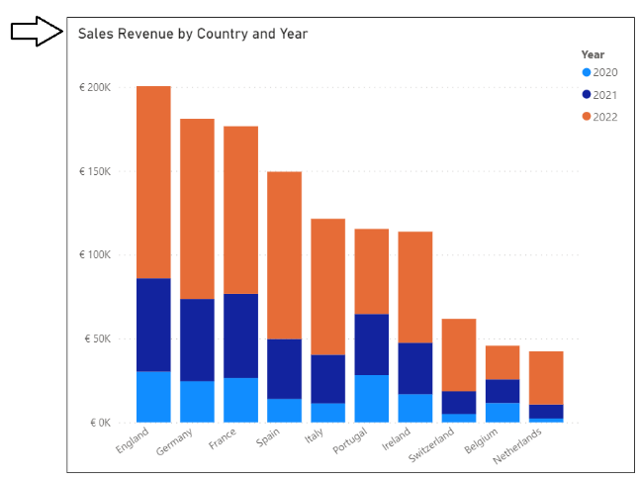

There is good news here. The default **Title** property for a Cartesian visual is dynamically parsed together in a fashion that supports localization. As long as you supply metadata translations for the names of columns and measures in the underlying dataset definition (e.g. **Sales Revenue**, **Country** and **Year**), the **Title** property of the visual will use the translations for whatever language has been used to load the report. The following table shows how the default **Title** property of this visual is updated for each language supported by the **ProductSalesMultiLanguage.pbix** live demo.

|  |  |
| --- | --- |
| Language | Visual Title |
| English (en-US) | Sales Revenue by Country and Year |
| Spanish (es-ES) | Ingresos por ventas por país y año |
| French (fr-FR) | Chiffre d’affaires par pays et année |
| German (de-DE) | Umsatz nach Land und Jahr |
| Dutch (nl-NL) | Omzet per land en jaar |

Even if you dislike the dynamically-generated visual **Title**, you must resist the temptation to replace it with a hard-coded text value. Any hard-coded text you type into the **Title** property of the visual will be added to the report layout and cannot be localized. Therefore, you should either leave the visual **Title** property with its default value or you should use the **Localized Table** strategy to create report labels that support localization.

### Introducing the Localized Labels Table Strategy

As discussed earlier in this article, the Power BI localization features are supported at the dataset level but not at the report layout level. At first you might ask the question “*how can I localize text-based values in a Power BI report that are not stored inside the dataset?”* The answer to this question is that there is no simple way to accomplish this. A better question to ask is “*how can I add the text-based values for report labels into the dataset as a dataset objects to enable localization support?”*

The idea behind the **Localized Labels** table isn’t all that complicated. It builds on the idea that Power BI supports metadata translations for dataset objects including measure. When you add a report label with Translations Builder, the tool automatically adds a new measure to the Localized Labels table behind the scenes. Once a measure has been created for each report label, Power BI can store and manage its translations in the exact same fashion that it does for metadata translations. In fact, the **Localized Labels** table strategy uses metadata translations to implement report label translations.

Translations Builder provides a convenient command to create the **Localized Labels** table. There are also other commands to add a measure each time you need a report label. The **Localized Labels** table is created as a hidden table behind the scenes. The idea is that you can do all the work to create and manage report labels inside the Translation Builder user experience. There is no need to inspect or modify the **Localized Labels** table using the Power BI Desktop dataset design experience.

Here's an example of the **Localized Labels** table from the live demo project **ProductSalesMultiLanguage.pbix**. As you can see it provides localized report labels for all titles, headings and button captions used throughout the report.

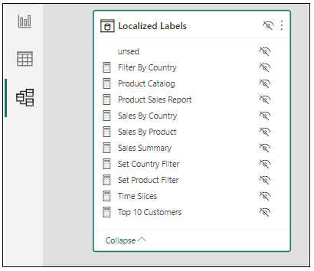

Translations Builder 1.0 introduced the **Localized Labels** table, but it did not take the strategy far enough. Consequently, it was petty awkward to surface report labels from the **Localized Labels** table directly on a report page. Translations Builder 2.0 introduces an evolved strategy to perform more work behind the scenes in order to make it easier and more natural for report designers to surface localized labels on a report page.

You can start by adding the **Localized Labels** table to a PBIX project by executing the **Create Localized Labels Table** command from the **Generate Translated Tables** menu.

When you execute this command to create the **Localized Labels** table, you will be prompted by the following dialog asking if you want more information about the **Localized Labels** table strategy. Interestingly enough, you’ll be redirect to this article if you click **Yes**.

After the **Localized Labels** table has been created, you will see three sample report labels as shown in the following screenshot. In most cases you will want to delete these sample report labels and replace them with those needed on the current project.

Remember, there is no need to interact with the **Localized Labels** table in Power BI Desktop. You can add and manage all the report labels you need using **Translations Builder**. To create your first report label, you can drop down the **Generate Translated Tables** menu and select **Add Labels to the Localized Labels Table**. Note you can also execute the **Add Labels to the Localized Labels Table** command using the shortcut key of **Ctrl+A**.

You can add report labels one at a time by typing in the text for the label and then clicking **Add Label**.

You can also move the **Add Localized Labels** dialog into advanced mode where you can delete all existing labels at once and enter a large batch of report labels in a single operation.

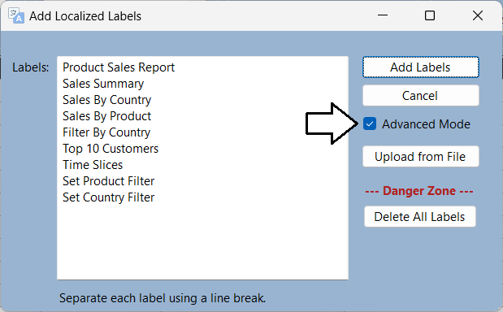

Once you have added a report label, it will appear in the translation grid as shown in the following screenshot.

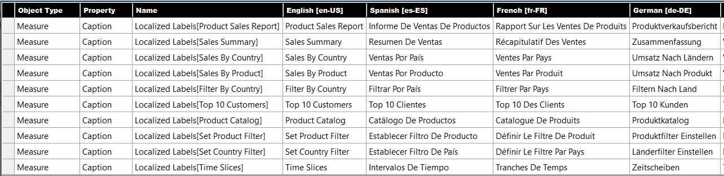

One valuable aspect of the **Localized Labels** table strategy is that report labels can be created, managed and stored in the same PBIX project files that holds the metadata translations for tables, columns and measures. The **Localized Labels** table strategy is able to merge metadata translations and report label translations together in the translation gird. There is no need to distinguish between metadata translations and report label translations when it comes to editing translations or generating machine translations.

There are other popular Power BI localization techniques that track translations for report label in a separate CSV file. While these techniques work just fine, they are not as streamlined as the **Localized Labels** table strategy because report label translations must be stored in a separate CSV file. These techniques also require that you deal with report label translations in a manner that is different from how you deal with metadata translations. With the **Localized Labels** table strategy, report label translations are treated the same and stored in the same PBIX file as metadata translations.

### Generating the Translated Localized Labels Table

There is one critical step you must always complete after modifying report labels in the **Localized Labels** table. More specifically, you must execute **Generate Translated Localized Labels Table** to create the measures that will be used to surface report labels on a report.

Here is what happens.

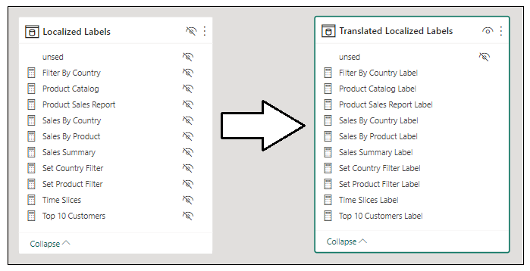

Any you add or update an report labels in the Localized Labels table, you will need to execute **Generate Translated Localized Labels Table**.

What do the measure look like? Great question.

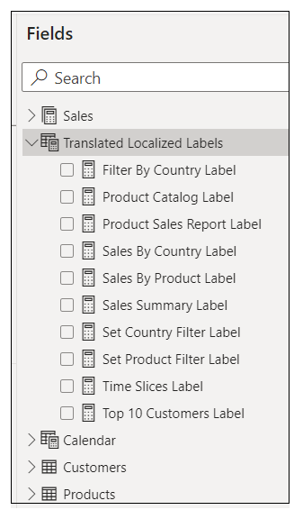

Xxxxxxx

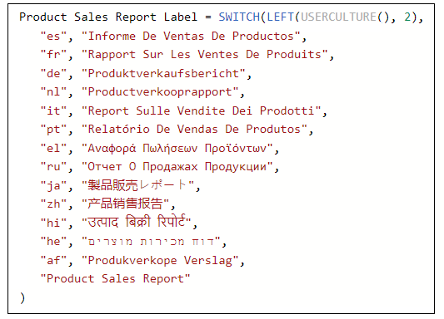

Explain USERCULTURE() function and explain how it enables localization opportunities

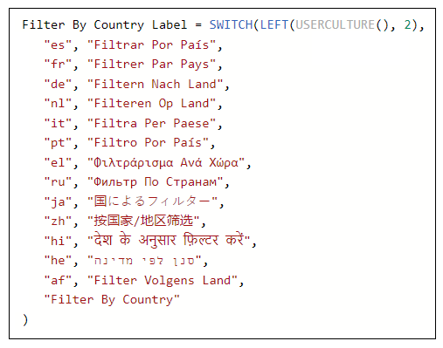

Remember to execute the **Generate Translated Localized Labels Table** command and time you make changes to the Localized Labels table.

Also, you should not edit the DAX expressions of measures in the **Translated Localized Labels** table. Any changes you make will be lost as all the measures in this table are deleted and recreated each time you execute **Generate Translated Localized Labels Table**.

### Surfacing Report Labels on a Report Page

Ddddddd

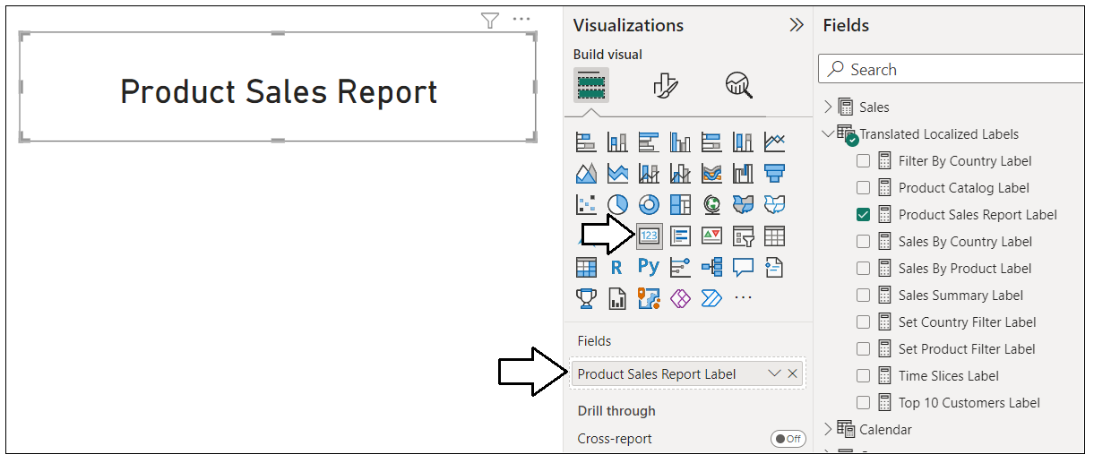

ccccc

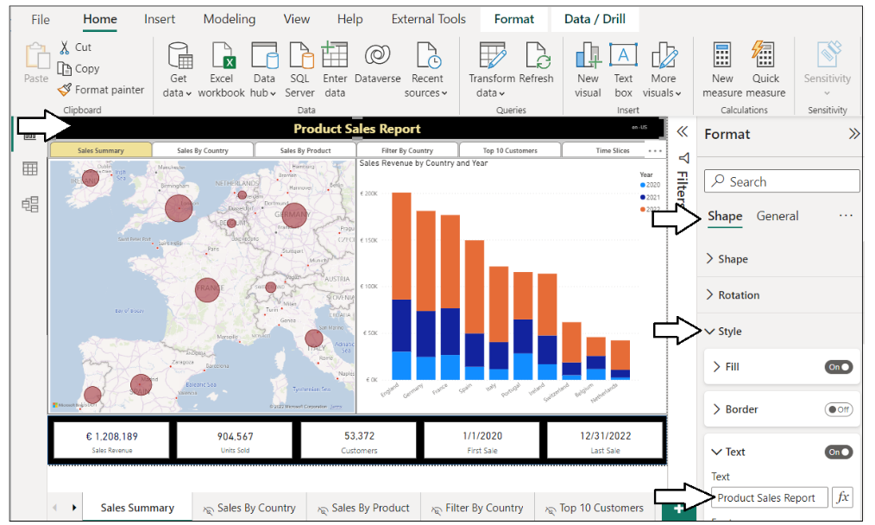

Xxxxx

Xxx

Xxxx

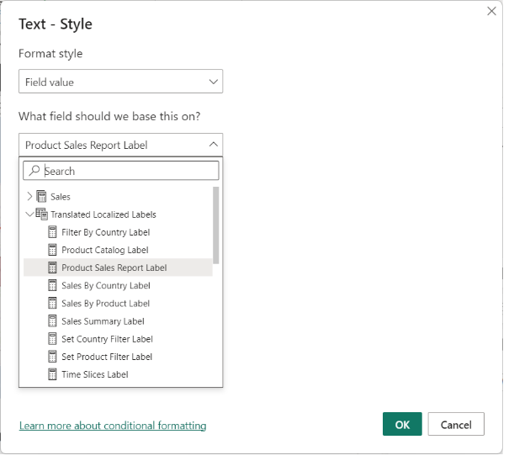

When it comes to localizing software, there are some universal principals to keep in mind. The first is to plan for localization from the start of any project. It's significantly harder to add localization support to an existing dataset or report that was initially built without any regard for Internationalization or localization. This is especially true with Power BI reports because there are so many popular design techniques that do not support localization. You might find that much of the work for adding localization support to existing Power BI reports involves moving backward and undoing the things that do not support localization before you can move forward with design techniques that do support localization.

Another important concept in localization is to plan for growth. A label that's 400 pixels wide when displayed in English could require a much greater width when translated into another language. If you optimize the width of your labels for text in English, you might find that translations in other languages introduce unexpected line breaks or get cut off which, in turn, creates a compromised user experience.

Adding a healthy degree of padding to localized labels is the norm when developing Internationalized software and it's essential that you test your reports with each language you plan to support. In essence, you need to ensure your report layouts looks the way you expect with any language you have chosen to support.

### Adding Support for Page Navigation

As you recall, you cannot display Power BI report page tabs to the user in a multi-language report because page tabs do not support localization. Therefore, you must provide some other means for users to navigate from page to page. This can be accomplished using a design technique where you add shapes to a report which act as buttons. When the user clicks on a shape, the shape will apply a bookmark to navigate to another page. Let's step through the process of building a navigation menu that supports localization using measures from the **Localized Labels** table.

The first thing you need to do is to hide every page in the report except for the first page which acts as the landing page.



Next, create a set of bookmarks. Each bookmark should be created to navigate to a specific page. The **live demo** sample demonstrates this technique by adding a bookmark for each page supported by the navigation menu.

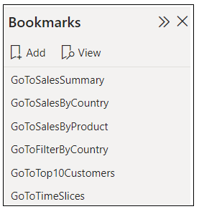

Cccc

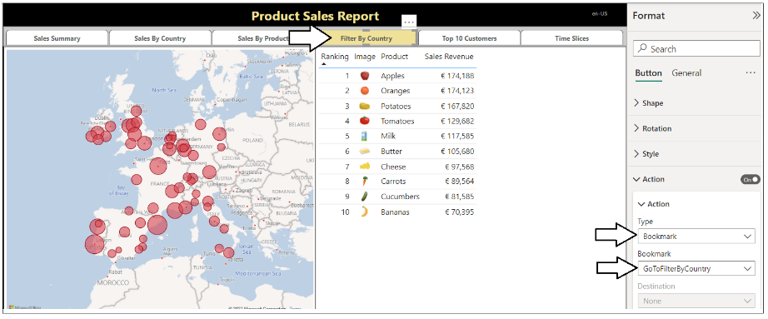

xxxx

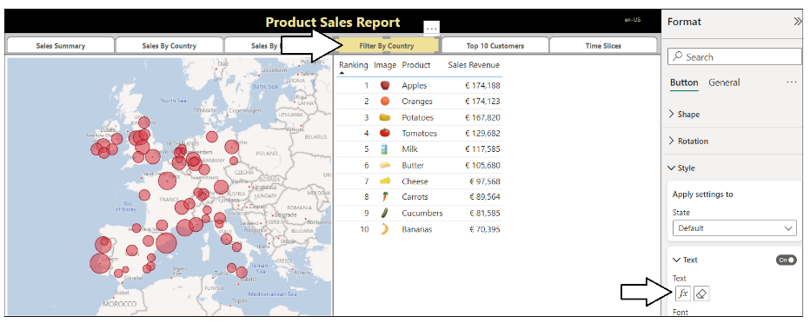

Xxx

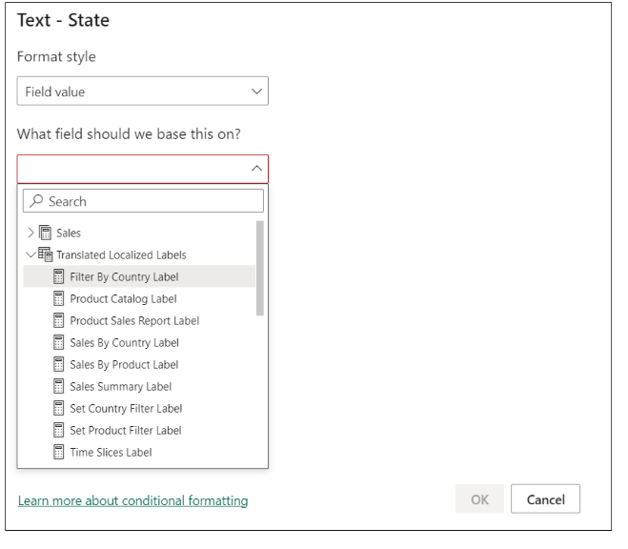

xxx

At this point, you've learned how to create the **Localized Labels** table and add labels. You also learned how to generate the Translated Localized Labels table and to bind the measures in that table to report elements such as Card visuals, shapes and buttons. These are the localization techniques you will continue to use as you create and maintain reports that must support multiple languages

### Enabling Human Workflows for Translation using Export and Import

Another important consideration when building multi-language reports involves the human aspect of translating text values from one language to another. While it's possible to generate the first round of metadata translations using machine translations, it's likely you will eventually need to integrate those friendly carbon-based life forms (i.e. people) who play the role of translators to generate high quality translations. Furthermore, you cannot expect that people who work as professional translators will be able or willing to use Power BI Desktop and Translations Builder.

The **TranslationsBuilder** introduces the concept of a translation sheet. A translation sheet is a CSV file that you generate with an export operation to send out to a translator. The translator performs the work to update the translation sheet and then returns it back to you. You can then execute an import operation the integrate the changes to translations by a translator back into the current PBIX project’s dataset.

When you click the **Export Translation Sheet** button, the **TranslationsBuilder** application generates a CSV file for the selected language using a naming format (e.g. **ProductSales-Translations-German.csv**) which includes the dataset name and the language for translation. After generating the file and saving it to the location of **TranslationsOutboxFolderPath** the **TranslationsBuilder** application will then open the translation sheet in Microsoft Excel.

Once these translation files have been generated, they can be sent out to the translation team. Once these translations files have been edited and returned with the high-quality human translations, you can then use the **Import Translations** command to important these human translations which will then effectively overwrite the machine translations.

This concludes the coverage of developing an external tool with custom code and TOM to automate the development tasks associated with creating and maintaining metadata translations in a multi-language reporting solution. Now it’s time to move ahead to the final section which addresses the ***why***, ***when*** and ***how*** of implementing data translations.

The **live demo** demonstrates how to implement localized labels in the report title and the top navigation menu buttons. The following screenshot shows the how button captions are translated when loaded with five different languages.

The live demo also demonstrates how to implement data translations. With metadata translations, you can see the names of columns and measures change as you switch between languages. Data translations go further to localize the product names in rows of the **Products** table. The following screenshot shows how the **ProductSales.pbix** developer sample provides data translations for product names as well.

## Implementing a Data Translations Strategy

While all multi-language reports will require metadata translations and report label translations, you cannot assume the same for data translations. Some projects will require data translations and others will not. In order the determine whether your project will require data translations, you'll need to think through the use cases you plan to support with your reporting solution. You will find that adding support for data translations can involve a good deal of planning and effort. You might decide to only support data translations if they are a hard requirement for your project.

Implementing data translations is quite different from implementing metadata translations or report label translations. They are different because Power BI doesn't offer any localization features to assist you with data translations. Instead, you must implement a data translation strategy which typically involves extending the underlying database with extrat columns to track translations for text in rows of data such as the names of products, categories and countries.

### Determine Whether Your Solution Really Requires Data Translations

To determine whether you need to implement data translations, start by thinking about how your reporting solution will be deployed and think about the use case for its intended audience. That leads to a key question. **Will you have people who speak different languages looking at the same database instance?**

Imagine a scenario where you are developing a report template for a SaaS application with a well-known database schema. Now let's say some customer maintain their database instance in English while others maintain their database instances in other languages such as Spanish or German. There is no need to implement data translations in this use case as the data from any database instance only needs to be viewed by users in a single language.

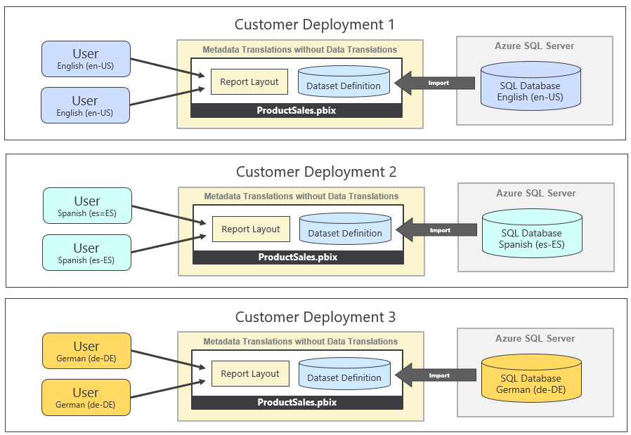

The important observation is that each customer deployment uses a single language for its database and all its users. Metadata translations must be implemented is this use case so you can deploy a single version of the PBIX file across all customer deployments. However, there is no need to implement data translations when no database instance ever needs to be viewed in multiple languages.

Now let's examine a different use case which introduces the requirement of data translations. This is the use case for the **ProductSales.pbix** developers sample which involves a single database instance containing sales performance data across several European countries. This reporting solution has the requirement to display its report in different languages while the data being analyzed is coming from a single database instance.

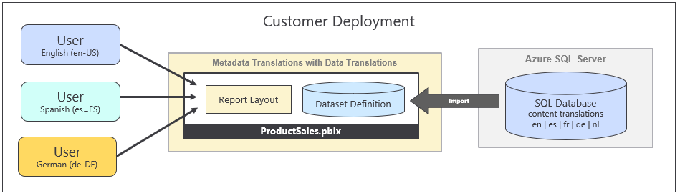

Once again, the key question to ask is whether you will have people who speak different languages looking at the same database instance. If the answer to that question is ***NO***, then you will not be required to implement data translations. If the answer to that question is ***YES***, then you should ask additional questions because there are other consideration you should think through before deciding whether it make sense to implement data translations.

When you're considering whether to implement data translations, you should examine the text-based columns which are candidates for translation to determine how hard will it be to translate those text value to secondary languages. Columns with short text values for things like product names, product categories and country names are a good candidates for data translations because the values are short and easy to translate. What if you have a column for product descriptions where each row has two to three sentences of text. While you can provide translations for product descriptions, they will require more effort to generate high quality translations. In general, columns with longer text values are less ideal as candidates for data translations.

You should also consider the number of distinct column values that will require translation. You can easily translate product names in a database that holds 100 products. You can probably translate product names when the number gets up to 1000. However, what happens if the number of translated values reaches 10,000 or 100,000. If you cannot rely on machine-generate translations. your translation team might have trouble scaling up to handle that volume of human translations.

You also have to consider that your commitment to implement data translations often requires on-going maintenance. Every time someone adds a new record to the underlying database, you might be required to add new data translations for it. This is very different from implementing metadata translations or report label translations where you create a finite number of translations for database objects and, after that point, your work is done. Metadata translations and report label translations don't require on-going maintenance as long as the underlying dataset schema and the report layout remain the same.

In summary, there are many factors that go into deciding whether you should implement data translations. You must decide whether you can afford to spend the time and effort it takes to implement data translations properly. You might decide that implementing metadata translations goes far enough. If your primary goal is to make your reporting solution compliant with laws or regulations, you might that find implementing metadata translations is all you need.

### Modify the Dataset Design to Support Data Translations

The recommended way

The following diagram shows the use case for the **ProductSales.pbix** developer sample. Note that this approach eliminates the need to redesign the underlying database to support data translations. Instead, all the ETL logic used to implemented data translations can be packaged and maintained inside a PBIX template file.

Now it's time to examine a few queries in the **ProductSales.pbix** developer solution so you can see how Power Query can be used to generate the extra rows required in the row replication pattern. Let's begin by examining the query named **Languages** which generates a table based on the following M code.

let

OutputSchema = type table [ LanguageTag=text, DisplayName=text, NativeName=text, SortOrder=number ],

Languages = #table(OutputSchema, {

{ "en-US", "English", "English", 1 },

{ "es-ES", "Spanish", "español", 2 },

{ "fr-FR", "French", "français", 3 },

{ "de-DE", "German", "Deutsch", 4 },

{ "nl-NL", "Dutch", "Nederlands", 5 }

})

in

Languages

The **Languages** query generates a table with a row for each language which will be used in the row expansion process.

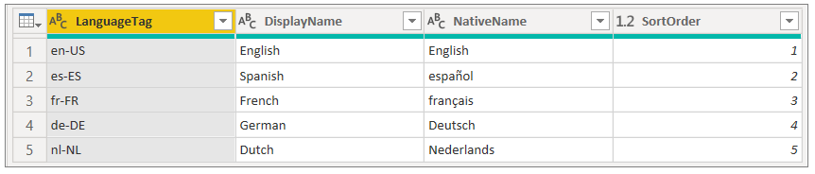

### Load Reports using Bookmarks to Filter Data Translations

Once you have created the Field Parameters to load \tables which use the row replication strategy, you must then figure out how to filter table rows so a user only sees the rows for one language at a time. In the **ProductSales.pbix** developer sample, the two tables that require filtering are **Products** and **Countries**. The following screenshot shows how you can use the **Filter** pane in Power BI Desktop to set report-level filtering on the **LanguageTag** column on both the **Products** table and the **Countries** table so only rows with **German** translations are displayed to the user.

The best way to control filtering in a Power BI report is to create a set of bookmarks. The **ProductSales.pbix** developer sample includes a set of bookmarks that can be used to apply the filtering required for each of the supported languages. Now you can simply apply a bookmark to set the data translations filtering as shown in the following screenshot.

Earlier in this article, you learned that it is possible to open a report in the Power BI Service using the **language** query string parameter to force a report to load the metadata translations for a specific language. Now that the report implements data translations in addition to metadata translations, it is now necessary to pass a second query string parameter to apply a bookmark. This query string parameter is named **bookmarkGuid** and it makes it possible to apply a bookmark as the report is loading before anything is displayed to the user.

## Summary

This article has examined how to use Power BI localization features to design and implement multi-language reports. Along the way you learned that Power BI datasets provide support for localization while the Power BI report designer does not. This partial support for localization in Power BI can lead to confusion as many common Power BI Desktop report design techniques do not support localization and must be avoided.

Becoming successful at building multi-language reports requires a deep understanding of Power BI architecture and a thorough knowledge of which report design techniques support localization. You 've learned how to prepare datasets and reports for localization and how to create the **Localized Labels** table so you can localize report labels such as titles, headings and button captions. You also learned several different approaches you can use to add metadata translations to a dataset definition. After reading this article, you should now possess a deeper understanding and the fundamental skills you need to build multi-language reports in a reliable and testable fashion.

This article also discussed when and how to implement data translations. You have learned that some projects will require data translations while other will not. You must decide whether to implement data translations on a project-by-project basis. Fortunately, you now know the right questions to ask in order to make that decision.

The **ProductSales.pbix** developer sample demonstrates how to implement data translations using the row replication pattern. While this design approach will work well for some scenarios, it might have trouble scaling in larger scenarios as the number of rows in the tables with translated content increases due to the use of many-to-many relationship. In the fullness of time, Power BI developers will continue to come up with creative and innovative designs to implement an efficient data translation strategy for these types of scenarios.